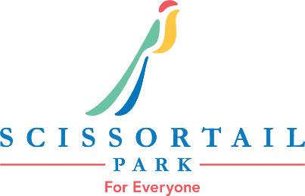

Myriad Gardens and Scissortail Park Foundation Job Description
Job Title: Food Service & Park Operations | FLSA Status: Non-exempt
Reports to: Park Attractions Manager | Work Schedule: Seasonal; Thursday through Sunday, weekends required; March - December
Approved by: | Date Approved:
This job description is not intended to be all-inclusive but rather to provide examples. This job description is subject to change.

Summary
Scissortail Park Foundation and Myriad Gardens Foundation are seeking energetic, friendly, and service-driven individuals to join our Seasonal Team. This seasonal position is responsible for delivering exceptional guest experiences through food service, attractions, and park operations in a fast-paced outdoor environment. Team Members assist guests while supporting daily park activities, special events, concessions, and attractions to help create a welcoming and enjoyable experience for all visitors.

Essential Duties and Responsibilities
- Enthusiastically greet and acknowledge every guest and respond appropriately to guest requests and questions.
- Prepare, serve, and sell food and beverages while maintaining food safety and sanitation standards.
- Operate point-of-sale systems accurately and efficiently; experience with Altru preferred.
- Assist with park attractions and operations including boats, rentals, carousel operations, and special events.
- Handle cash, inventory, and daily sales transactions accurately.
- Maintain neat, clean, and organized work areas.
- Follow all Foundation policies, procedures, and safety guidelines.
- Work collaboratively with team members to ensure exceptional guest experiences.
- Assist with additional duties and special projects as assigned.

Supervisory Responsibilities
None

Education and/or Experience
- High school diploma or equivalent preferred
- Customer service or food service experience preferred

Computer Equipment and Software Requirements
- Experience in use of standard office equipment such as email, Microsoft Word, internet, etc.

Certificates, Licenses, Registrations
- Valid Oklahoma driver’s license
- Food Handler Certificate required or obtained upon hire

Skills and Abilities Required
- Strong communication and customer service skills.
- Ability to work effectively in a fast-paced environment.
- Ability to interact professionally with diverse audiences.
- Ability to accurately handle cash and sales transactions.
- Ability to work a flexible schedule including evenings, weekends, and holidays.
- Ability to learn and adapt to new processes and procedures.
- Demonstrate enthusiasm and excitement for park programs, attractions, and events.
Additional Job Requirements
Clearance of background check

Work Environment
The employee will work primarily in an outdoor park environment approximately 15–30 hours per week. Work may include exposure to varying weather conditions, large crowds, and special events. Evening, weekend, and holiday work is required based on operational needs and event schedules.

Physical Requirements
- Ability to stand and walk for extended periods of time
- Ability to lift up to 50 pounds
- Ability to bend, stoop, squat, and climb stairs on occasion
- Must be able to work outdoors in varying weather conditions

The qualifications, physical demands, and work environment described herein are representative of those an employee will encounter and must meet to successfully perform the essential functions of this job. Reasonable accommodations may be made to enable individuals with disabilities to perform the essential functions. The requirements listed in this document are the minimum levels of knowledge, skills, or abilities.

